Exp No. -4 Create a simple cloud software application for Library book reservation system for SIMATS library using any Cloud Service Provider to demonstrate SaaS
Done by: Juhi Surin
Register no.: 192525148

Aim:
To develop a cloud-based Library Book Reservation System for SIMATS Library using Zoho Creator (SaaS) to enable students to reserve books online.

Procedure:
- Log in to Zoho Creator and create a new application named Library Book Reservation System.
- Create a Library Book Reservation Form with the required fields.
- Configure field types such as dropdown, date, email, and number.
- Create an On Success workflow to display a reservation confirmation message.
- Enter sample reservation details and submit the form.
- Verify that the reservation details are stored successfully in the cloud.

Implementation Steps:
- Open Zoho Creator and create the application.
- Design the reservation form with student and book details.
- Add validation and appropriate field properties.
- Create the workflow using Deluge script.
- Test the application with sample records.
- Confirm that the reservation data is saved and the confirmation message is displayed.

Output:
- Form

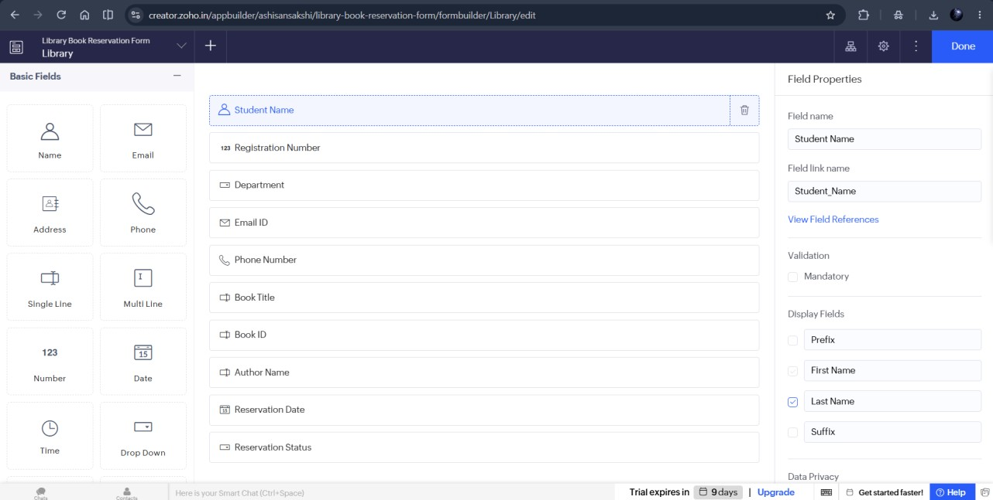

- Workflow
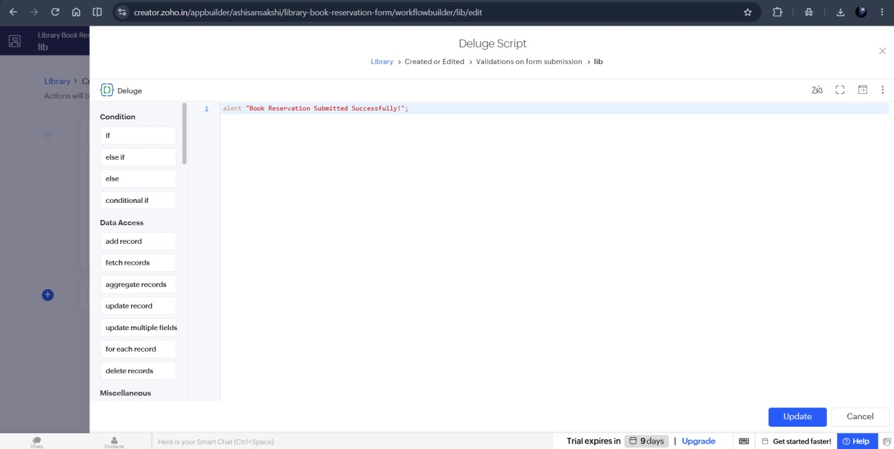

- Report
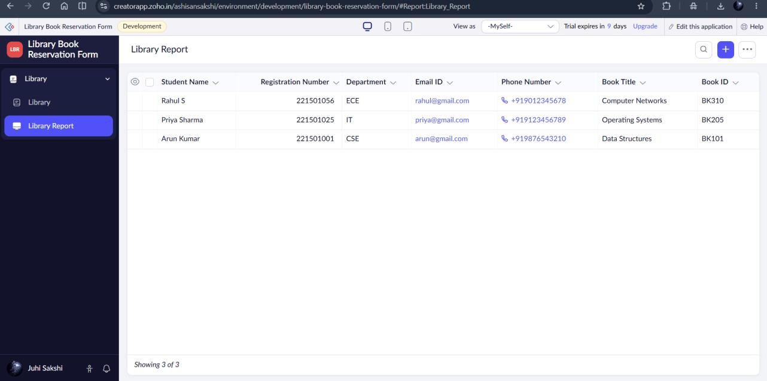

Result:
Thus, a cloud-based Library Book Reservation System for SIMATS Library was successfully developed using Zoho Creator (SaaS), enabling students to reserve library books online.

